**SUSTAINABLE OUTREACH AND UNIVERSAL LEADERSHIP LIMITED  
(SOUL)**



**PROJECT BEPC**

**BEPC USER MANUAL**

**VERSION HISTORY**

|  |  |  |  |  |
| --- | --- | --- | --- | --- |
| **Date** | **Version No.** | **Created By** | **Updated Section** | **Updated By** |
| 06-09-2022 | Version 0.1 | Subhodeep Dey |  |  |
| 07-10-2022 | Version 0.2 |  | BEPC Users, User Access and Privilege, Table of figures, all screen shots | Sharmistha Panda |

Table of Contents

Introduction 8

Purpose and Scope 8

BEPC Users 8

User Access and Privileges 8

1. Login 9

1.1. Login with Email-ID 9

1.2. How to Change Password 10

2. State 11

1.3. How to Create State 12

3. District 13

1.4. How to Create District 13

4. Block 14

1.5. How to Create Block 14

5. School Master Form 15

5.1. How to Create School Masters Form 15

6. School Survey Form 17

1.6. How to Create School Survey Form 17

7. Electricity Consumption Record 19

1.7. How to Create Electricity Consumption Record 19

8. Internet Consumption Record 21

1.8. How to Create Internet Consumption Record 22

9. Teacher 23

1.9. How to Create Teacher 23

10. Teacher Group 24

1.10. How to Create Teacher Group 25

11. School Consent form for Teacher Training 26

1.11. How to Create School Consent form for Teacher Training 27

12. Teacher Training 28

1.12. How to Create Teacher Training 29

13. Student Entry 32

The Student Entry is used to keep a class-wise records of students in a school. 32

1.13. How to Create Student Entry 32

14. Item 34

You can add an Item as per requirement and its reference insurance company so that you can track which item is insured by which insurance company. 34

34

1.14. How to Create Item 34

35

15. Insurance Company 35

1.15. How to Create Insurance Company 36

16. School Wise Equipment List 36

1.16. How to Create School Wise Equipment List 37

17. Theft Case Record 38

Theft Case Record is used to record theft cases of the items used in the organization 38

Home > BEPC > Theft & Insurance Master > School Wise Equipment List 38

38

1.17. How to Create Theft Case Record List 39

39

18. School Survey Form Update Status 39

19. School Wise Student 41

20. Figure 55: School Wise Student Report 42

21. Electricity Usage Details 42

22. Internet Usage Details 43

23. School Wise Equipment List 44

24. Teacher Training Report 45

25. Theft Report 46

47

26. BEPC Support 48

1.18. Support Settings 48

48

49

1.19. Service Level Agreement 49

1.20. Features of Service Level Agreement 52

>> Applies to New Issues 52

>> Resetting an SLA 52

>> Time respond / resolve in Issues 52

>> Pause SLA on Statuses 53

1.21. Issue Priority 55

1.22. Issue Type 56

1.23. Issue 57

Table of Figures

Figure 1 : Login Screen 7

Figure 2 : Login with Email-ID 8

Figure 3 : Click on Profile 8

Figure 4 : Enter Password 9

Figure 5 : State 10

Figure 6 : New State 10

Figure 7 : District 11

Figure 8 : New District 11

Figure 9 : Block 12

Figure 10 : New Block 12

Figure 11 : School Masters Form 13

Figure 12 : New School 14

Figure 13 : Survey > School Survey Form 15

Figure 14 : New School Survey Form 16

Figure 15 : Electricity Data Management > Electricity Consumption Record 17

Figure 16 : New Electricity Consumption Record 18

Figure 17 : Select ‘My Device’ after clicking attach button 18

Figure 18 : Internet Data Management > Internet Consumption Record 20

Figure 19 : New Internet Consumption Record 20

Figure 20 : School Masters > Teacher 21

Figure 21 : School Masters > New Teacher 21

Figure 22 : School Masters > Teacher Group 23

Figure 23 : New Teacher Group 23

Figure 24 : On Click of the Add Row button 24

Figure 25 : School Masters > School Consent for TT 25

Figure 26 : School Masters > School Consent form for Teacher Training 25

Figure 27 : On Click of the Add Row button 26

Figure 28 : School Masters > Teacher Training 27

Figure 29 : New Teacher Training 27

Figure 30 : On Click of the Add Row button 28

Figure 31 : On Click of the Add Row button 28

Figure 32 : On Click of the Add Row button Training Photos Attachment 28

Figure 33 : On Click of the Add Row button Training Recording Attachment 29

Figure 34 : On Click of the Add Row button Training Assessment Attachment 29

Figure 35 : Feedback Attachment and Venue Pictures 29

Figure 36 : My Device to upload files/photos from your system 29

Figure 37 : School Masters > Student Entry 30

Figure 38 : New Student Entry 31

Figure 39 : On Click of Add Row button 31

Figure 40 : Theft & Insurance Master > Item 32

Figure 41 : New Item 33

Figure 42 : Theft & Insurance Master > Insurance Company 34

Figure 43 : New Insurance Company 34

Figure 44 : Theft & Insurance Master > School-Wise Equipment List 35

Figure 45 : New School-Wise Equipment List 35

Figure 46 : On Click of Add Row Button 36

Figure 47 : Theft Insurance Monitor > Theft Case Record 36

Figure 48 : New Theft Case Record 37

Figure 49 : Survey Form Update Status 37

Figure 50 : School Survey Form Status Filters 38

Figure 51 : School Survey Form Status Filters 38

Figure 52 : School Survey Form Status 39

Figure 53 : School Survey Form Status workflow state 39

Figure 54 : School Wise Student 40

20. Figure 55 : School Wise Student Report 40

Figure 56 : Electricity Usage Details 41

Figure 57 : Electricity Usage Details Report 41

Figure 58 : Internet Usage Details 42

Figure 59 : Internet Usage Details Report 42

Figure 60 : School Wise Equipment List 43

Figure 61 : School Wise Equipment List 43

Figure 62 : Teacher Training Report 44

Figure 63 : Teacher Training Report 44

Figure 64 : Theft Report Navigation 45

Figure 65 : Theft Report 45

Figure 66 : Support Settings 46

Figure 67 : Support Settings screen 47

Figure 68 : Support Settings - track SLA 48

Figure 69 : Response and Resolution Time 49

Figure 70 : SLA Support Hours 49

Figure 71 : SLA Entity Type 50

Figure 72 : Time to respond 51

Figure 73 : Pause SLA 51

Figure 74 : Hold Indicator 52

Figure 75 : Total Hold Time 52

Figure 76 : Issue Priority 53

Figure 77 : New Issue Priority 53

Figure 78 : Issue Type 54

Figure 79 : New Issue Type 54

Figure 80 : Support > Issue 55

# Introduction

**The user manual is designed to provide relevant, and content specific information for the user to use the Survey Forms, Electricity and Internet Consumption Form and various reports of the BEPC Module in the BEPC product.**

# Purpose and Scope

**The purpose of the document is to provide user a step-by-step guidance to fill up the Survey and other Forms and generate insightful reports according to necessity.**

# BEPC Users

**The system shall be available and accessible by the following set of users:**

* Management (Product Owner)
* Project Manager (PM)
* District Coordinator (DC)
* Executive Help-desk

# User Access and Privileges

|  |  |
| --- | --- |
| ****User**** | ****Screen(s) Accessible**** |
| **Management** | **Dashboard, Reports** |
| **Project Manager** | **School Master,School Survey forms, Electricity Consumption Record,Internet consumption Record,Equipment Uptime,School wise Equipment List,State, District, Block,Teacher, Teacher Group,School Consent form for Teacher Training,Teacher Training,Item,Theft Case Record,Issue, Issue Type,Issue Priority,Service Level Agreement,Support Settings** |
| **District Coordinator** | **Electricity Consumption Record,School wise Equipment List,Teacher Group,School Consent form for Teacher Training,Teacher Training,Theft Case record,Issue** |
| **Executive Help-desk** | **School Master, School Survey form,Electricity Consumption Record,Internet consumption Record,Equipment Uptime,Theft Case Record,Issue, Issue Type,Issue Priority** |

# Login

**BEPC Users will navigate to the URL and enter their credential in the screen as shown below**

**URL -** <https://testbepc.eduleadonline.com/>

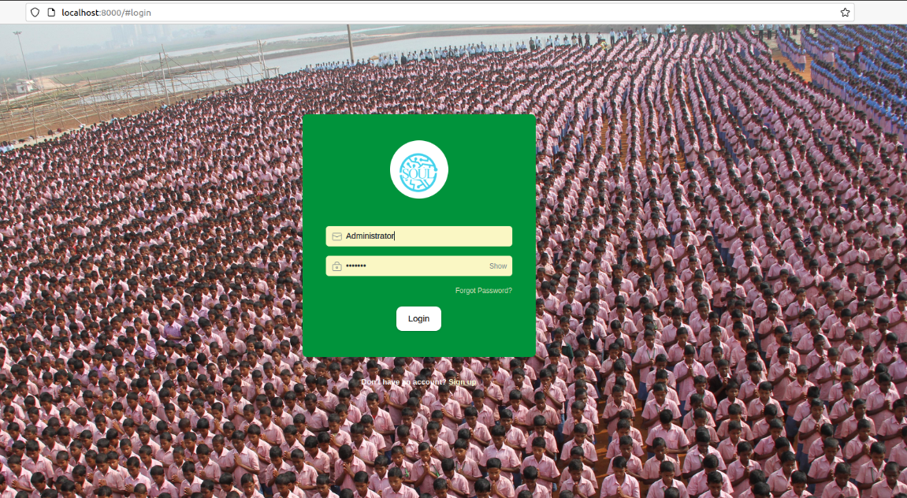

Figure 1: Login Screen

* 1. ****Login with Email-ID****

**BEPC Users can login to the screen with their Email-ID**

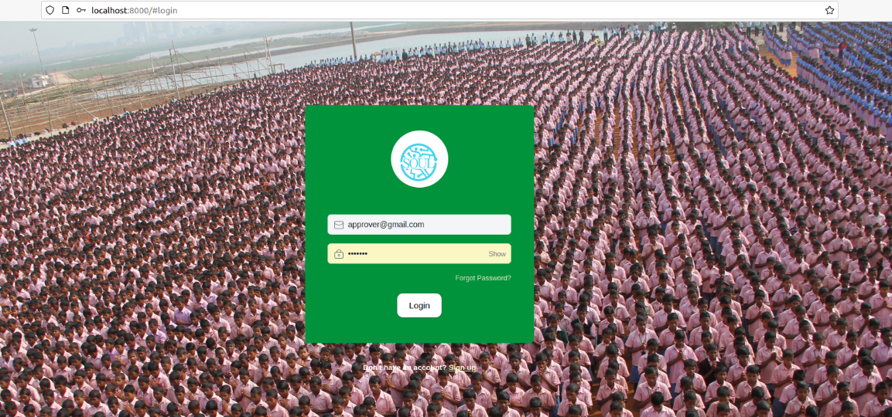

Figure 2: Login with Email-ID

* 1. ****How to Change Password****

1. **Log in to Application**
2. **Click on Profile initials (as shown below)**

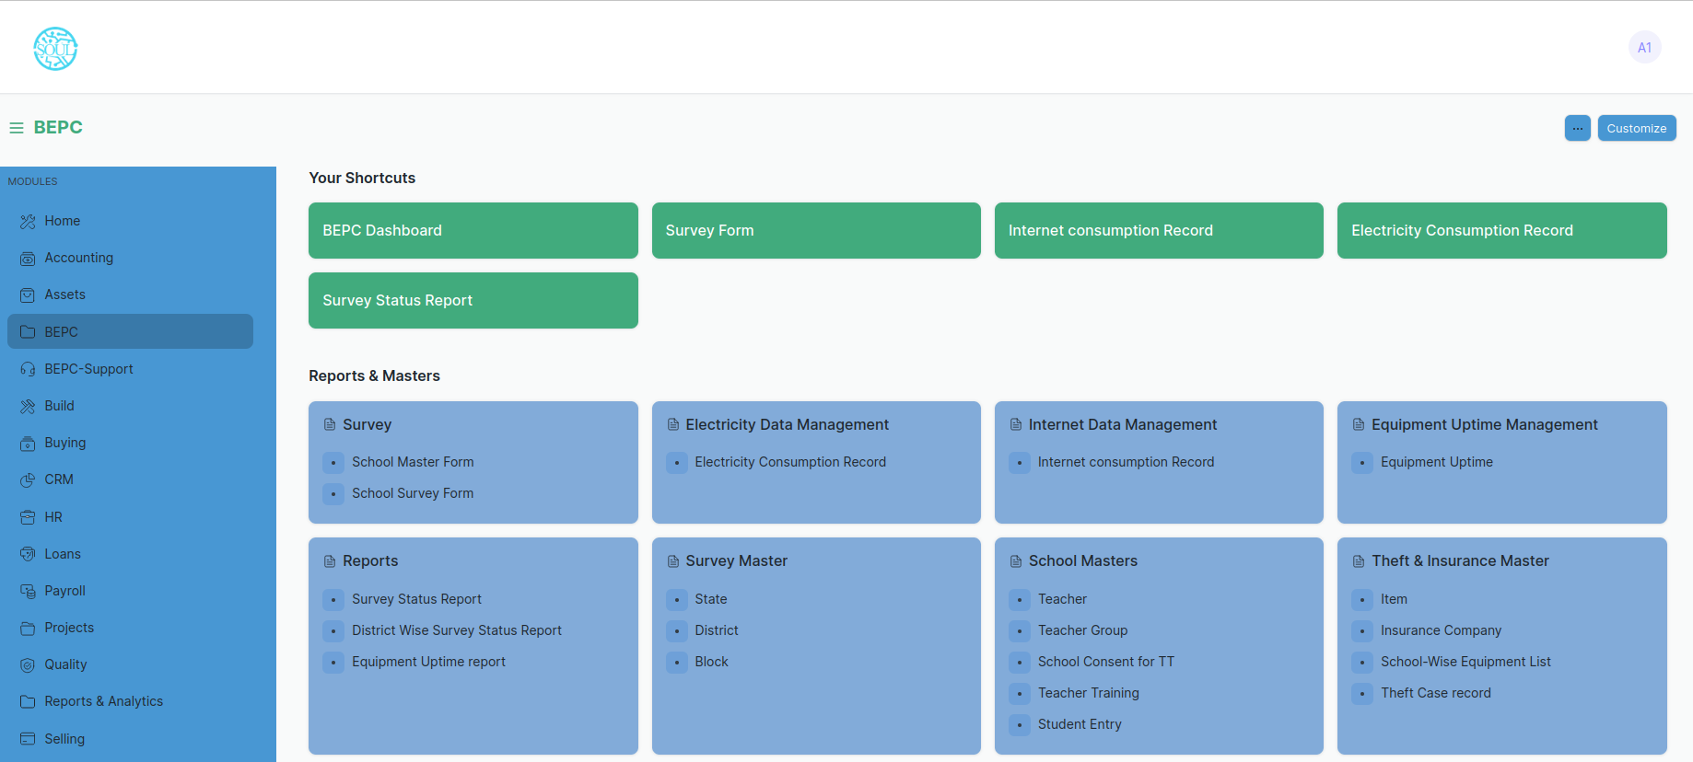

Figure 3: Click on Profile

1. **Go to My Settings**
2. **Scroll to Change Password field**

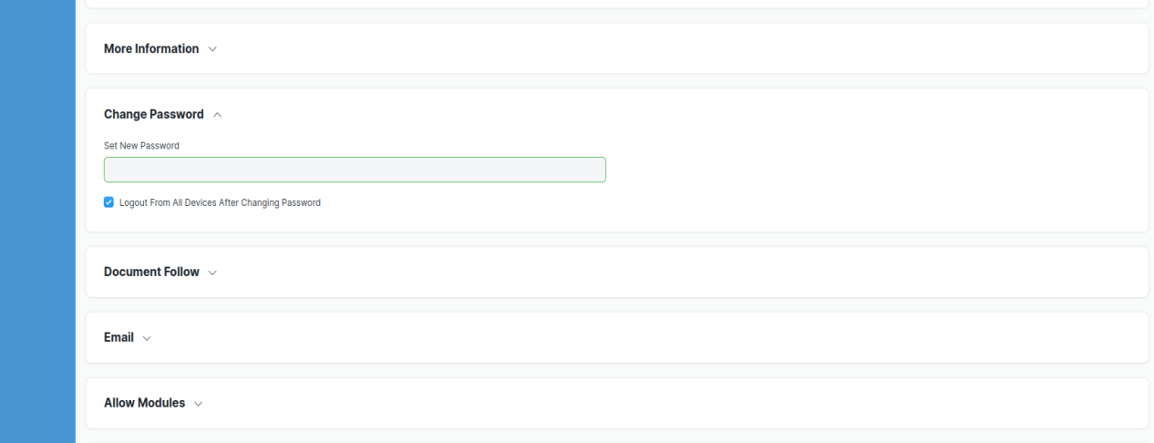

Figure 4: Enter Password

1. **Enter the password**
2. **Click Save**

# State

**State is a master data which is used as a link to the states of the schools.**

**Home > BEPC > Survey Master > State**

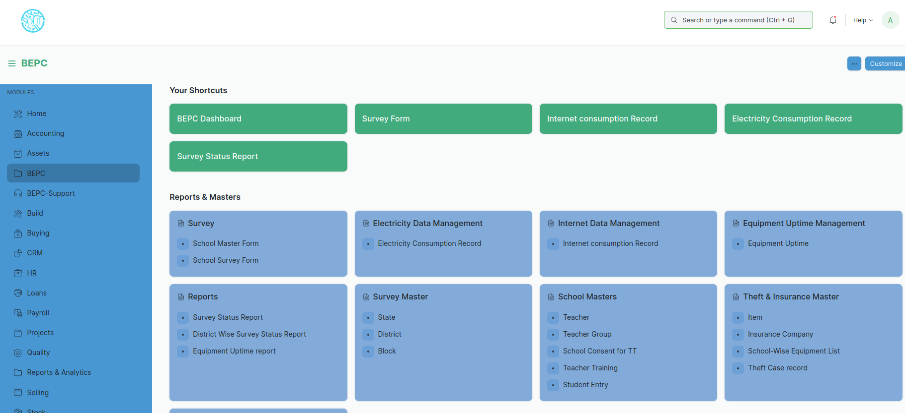

Figure 5: State

* 1. ****How to Create State****

1. **Go to State**
2. **Click on + Add State**
3. **Enter State Name, Country and Description**
4. **Click on Save button**

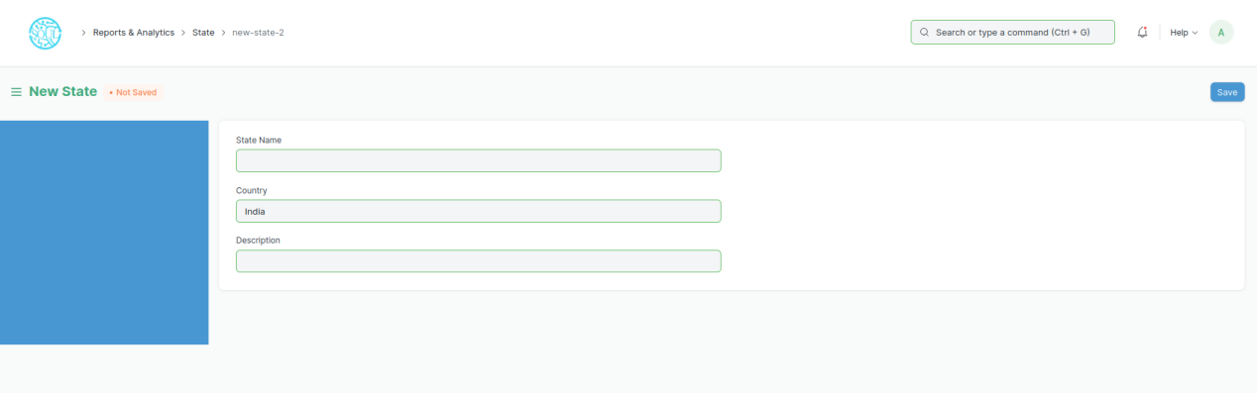

Figure 6: New State

# District

**District is a master data which is used as a link to the states of the schools.**

**Home > BEPC > Survey Master > District**



Figure 7: District

* 1. ****How to Create District****
* **Go to State Survey Form**
* **Click on + Add District**
* **Enter State, District**
* **Click on Save button**

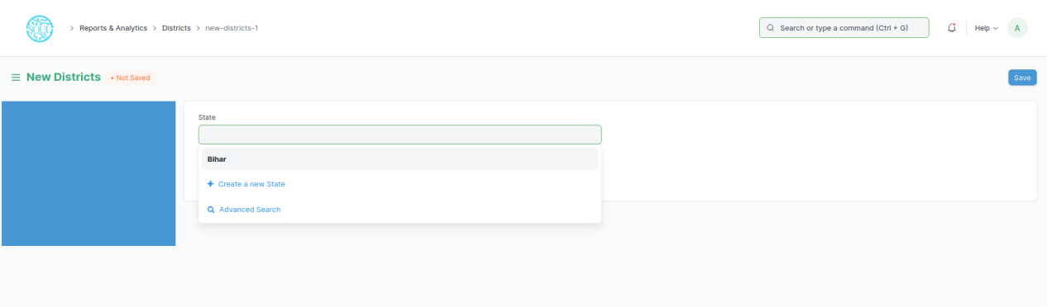

Figure 8: New District

# Block

**District is a master data which is used as a link to the states of the schools.**

**Home > BEPC > Survey Master > Block**



Figure 9: Block

* 1. ****How to Create Block****
* **Go to Block**
* **Click on + Add Block**
* **Enter State, District, Block**
* **Click on Save button**

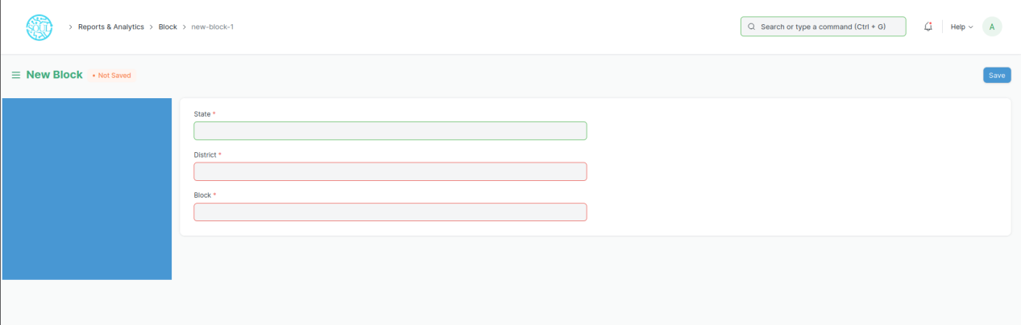

Figure 10: New Block

# School Master Form

**Prior to adding a School Survey Form, the following must be created:**

* [State](https://docs.erpnext.com/docs/v13/user/manual/en/human-resources/employee)
* District
* Block

**School Master Form is a form which contains information regarding the relevant schools.**

**Home > BEPC > Survey > School Master Form**



Figure 11: School Masters Form

****5.1. How to Create School Masters Form****

1. **Go to School Masters Form**
2. **Click on the + Add School**
3. **Enter School Code, School Name, UDISE which are mandatory**
4. **You can also enter Cluster Name, Zone, Postal Address, State, Pin Code, District, Panchayat, Block, Near Landmark, School Mail ID, School Contact No., Name Of President, President Contact No, Name of Headmaster/Head Mistress, Headmaster/Head Mistress Contact No, Name of Asst (HM/HMS), Asst Contact number, Latitude and Longitude**
5. **Click on the Save button**

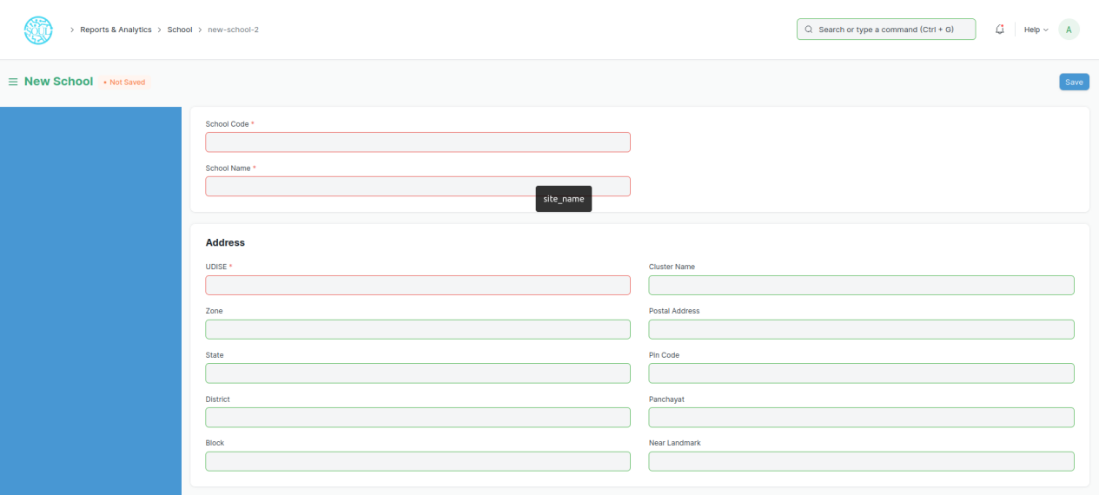

Figure 12: New School

# School Survey Form

**Prior to adding a School Survey Form, the following must be created:**

* [School](https://docs.erpnext.com/docs/v13/user/manual/en/human-resources/employee) Master Form (School)

**School Survey Form is incorporated to take a detailed survey of various schools to gain insightful information on the operational and administrative domains.**

**Home > BEPC > Survey > School Survey Form**



Figure 13: Survey > School Survey Form

**Prior to adding a School Survey Form, the following must be created:**

* [School](https://docs.erpnext.com/docs/v13/user/manual/en/human-resources/employee) Master Form (School)
  1. ****How to Create School Survey Form****
* **Go to School Survey Form**
* **Click on + Add School Survey Form**

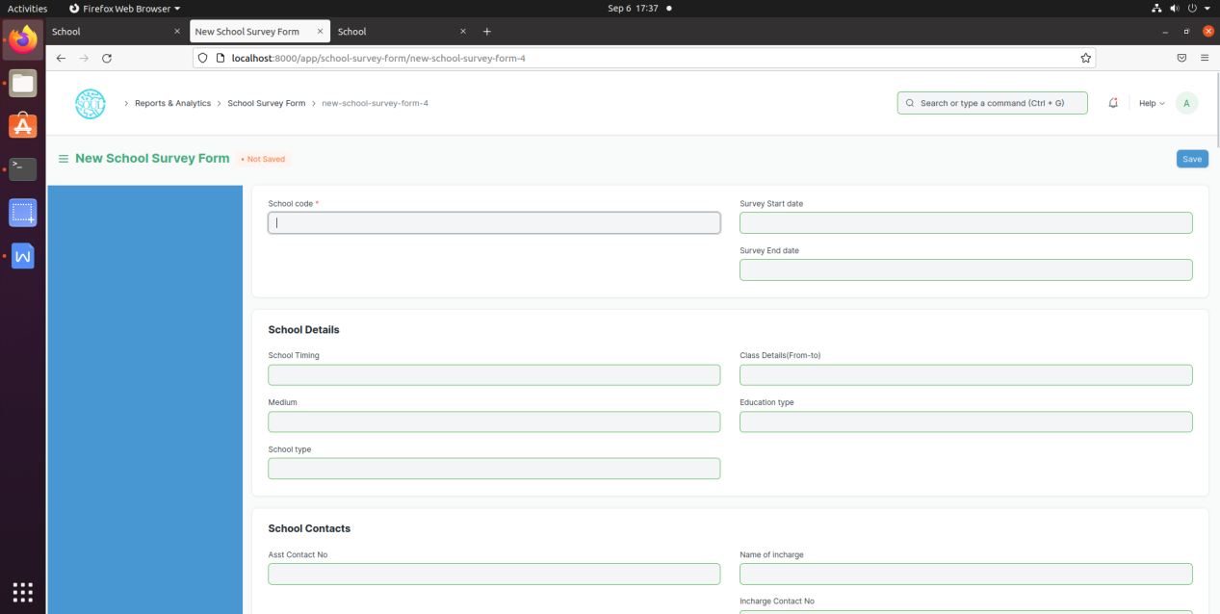

Figure 14: New School Survey Form

* **Enter School Code, Survey Start Date, Survey End Date**
* **Enter relevant information to the fields present in the sections such as, School Details, School Contacts, Class Wise Students, School Details, IT Infra Details, Electricity Details, School Route Details, Prefer Better ISP, Room Details for Lab-1, Room Details for Lab-2, Safety measures, Bank details of School, District Monitoring, Teacher Details for training, Remarks.**
* **Click on the Save button**

# Electricity Consumption Record

**Electricity Consumption Record is used to keep records of the electricity consumption of various schools. It is used to keep track of the meter readings for previous month and the present month and find the difference between the two which is reflected as sub-meter reading.**

**Home > BEPC > Electricity Data Management > Electricity Consumption Record**



Figure 15: Electricity Data Management > Electricity Consumption Record

* 1. ****How to Create Electricity Consumption Record****
* **Go to Electricity Consumption Record**
* **Click on + Add Electricity Consumption Record**

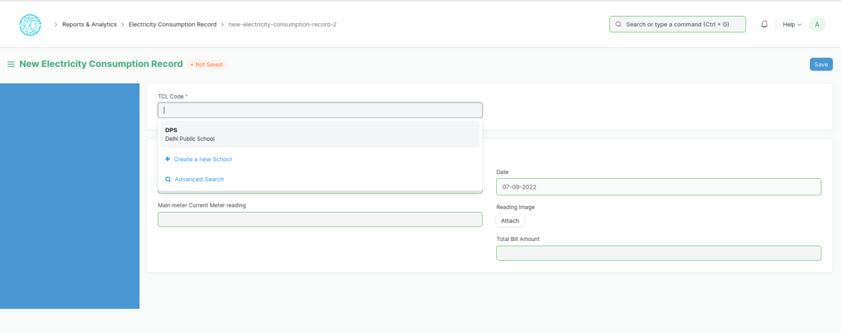

Figure 16: New Electricity Consumption Record

* **Enter TCL Code of the School**
* **Add the past Meter reading in the field ‘Main meter Previous Meter Reading’**
* **Add the current Meter reading in the field ‘Main meter Current Meter Reading’**
* **Attach the meter reading image by clicking on attach button called ‘Reading Image’. After clicking on the attach button select ‘my device’ and select the image from your computer.**

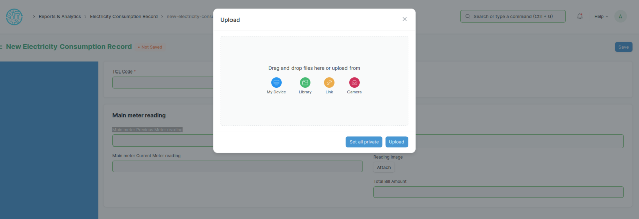

Figure 17: Select ‘My Device’ after clicking attach button

* **Enter the Total Bill Amount in the respective field**
* **Click on the Save button to save the form**
* **After you save the form the sub meter reading will appear under the field ‘Main meter Current Meter Reading’**

# Internet Consumption Record

**Internet Consumption Record is used to monitor the internet consumption of various schools. It is used to keep track of the Internet Service Provider(ISP), Data Usage and Monthly Bill Amount charge by that ISP.**

**Home > BEPC > Internet Data Management > Internet Consumption Record**



Figure 18: Internet Data Management > Internet Consumption Record

* 1. ****How to Create Internet Consumption Record****
* **Go to Internet Consumption Record**
* **Click on + Add Internet Consumption Record**

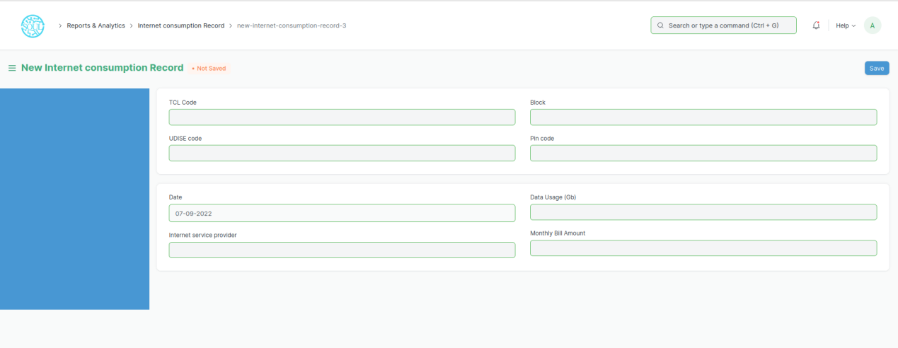

Figure 19: New Internet Consumption Record

* **Enter TCL Code of the School**
* **Add the name of ISP in the field ‘Internet Service Provider’**
* **Add the amount of data used(in gigabytes) in the month in the field ‘Data Usage(Gb)’**
* **Enter the Monthly Bill Amount in the respective field**
* **Click on the Save button**

# Teacher

**This form allows us to store the details of the teachers/faculty with respect to the schools they teach at. This also contains the contact details of the teachers/faculty.**

**Home > BEPC > School Masters > Teacher**



Figure 20: School Masters > Teacher

* 1. ****How to Create Teacher****
* **Go to Teacher**
* **Click on + Add Teacher**

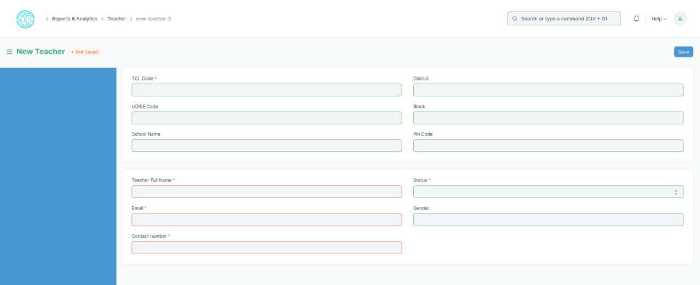

Figure 21: School Masters > New Teacher

* **Enter TCL Code of the School in which the teacher belongs**
* **Enter the Teacher’s Full Name in the field ‘Teacher Full Name’**
* **Enter the email of the teacher in the field ‘Email’**
* **Enter the contact number of the teacher in the field ‘Contact Number’**
* **In the field called ‘Status’ select the status of the teacher(Active/Inactive) so that it can be determined whether the teacher is active or not.**
* **Enter the gender of the teacher in the field called ‘Gender’**
* **Click on the Save button**

# Teacher Group

**Prior to adding a Teacher Group, the following must be created:**

* Teacher

**A Teacher Group is used to consolidated all teachers in a single space based on either school, district or block.**

**Home > BEPC > School Masters > Teacher Group**

Figure 22: School Masters > Teacher Group

* 1. ****How to Create Teacher Group****
* **Go to Teacher Group**
* **Click on + Add Teacher Group**

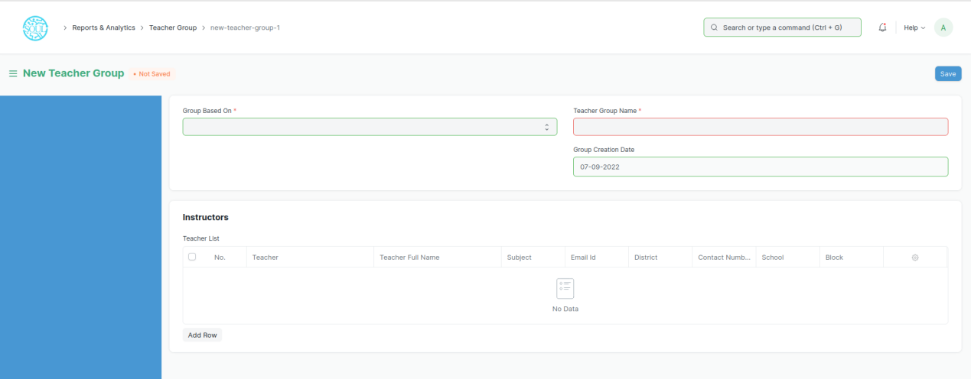

Figure 23: New Teacher Group

* Select the criteria based on which you need to create the teacher group i.e. School, District and Block in the field ‘Group Based On’
* Enter the name of the group in the field “Teacher Group Name”
* Now you are ready to add your teachers to the group
* To add teachers to the group Click on “Add Row” button present beneath the table called Teacher List
* Once you press the “Add Row” button, a row will be added to the table

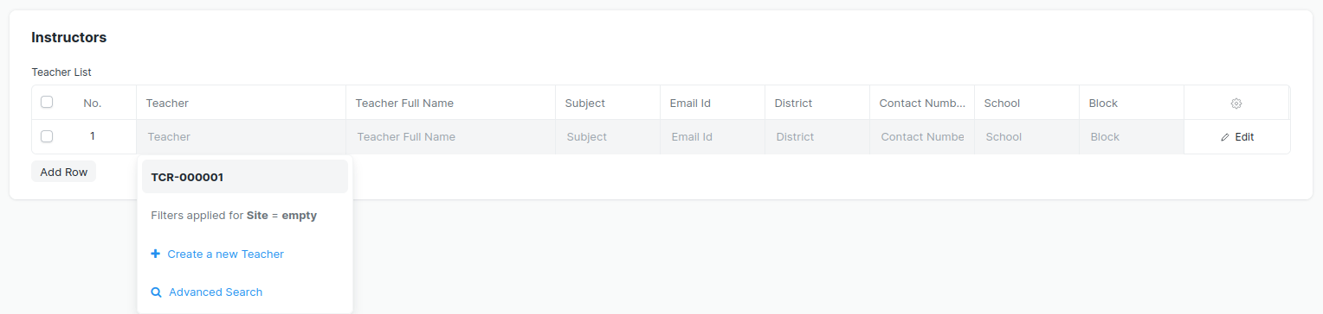

Figure 24: On Click of the Add Row button

* **Once the row is added**, **select the teacher by clicking on the teacher field on that row**
* **After teacher selection**, **all the details of that teacher will be fetched on the row**
* **Click on the Save button**

# School Consent form for Teacher Training

**This form is used to store the information of teachers who have the consent for Teacher Training.**

**Prior to adding a School Consent form for Teacher Training, the following must be created:**

* Teacher

**Home > BEPC > School Masters > School Consent form for Teacher Training**



Figure 25: School Masters > School Consent for TT

* 1. ****How to Create School Consent form for Teacher Training****
* **Go to School Consent form for Teacher Training**
* **Click on + Add School Consent form for Teacher Training**

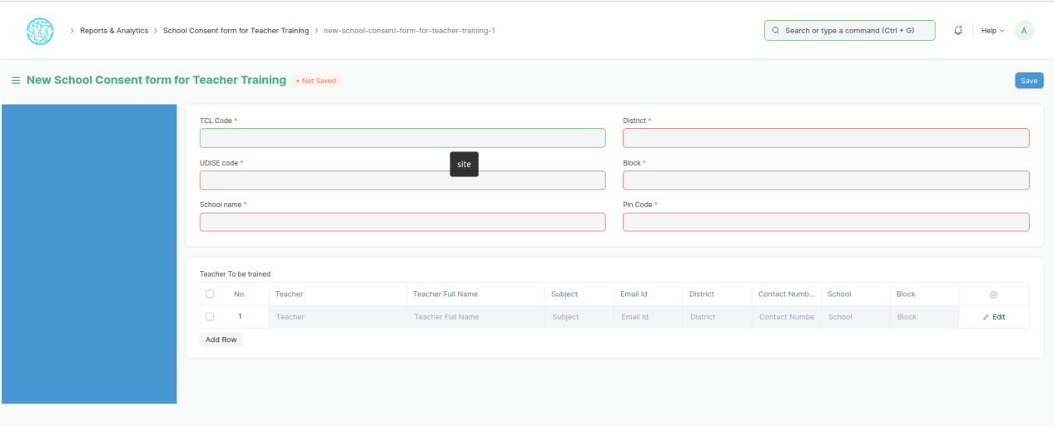

Figure 26: School Masters > School Consent form for Teacher Training

* **Enter the TCL code of the school for which consent is to be given**
* **Go to the table called ‘Teacher To be trained’**
* **To add teachers to the group Click on** “**Add Row” button present beneath the table**

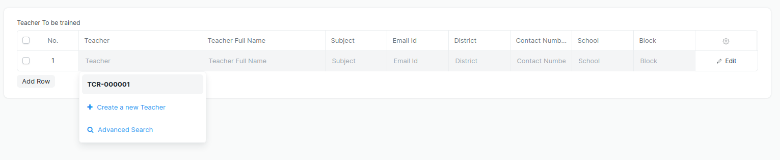

Figure 27: On Click of the Add Row button

* **Once the row is added**, **select the teacher by clicking on the teacher field on that row**
* **After teacher selection**, **all the details of that teacher will be fetched on the row**
* **Click on the Save button**

# Teacher Training

**The Teacher Training form is used to consolidate Schools and Trainers related to Teacher Training. Moreover the training details, participants and required attachments of the documents are maintained in this form.**

**Prior to adding a Teacher Training record, the following must be created:**

* Teacher
* School
* Teacher Group
* School Consent for Teacher Training

**Home > BEPC > School Masters > Teacher Training**

Figure 28: School Masters > Teacher Training

* 1. ****How to Create Teacher Training****
* **Go to Teacher Training**
* **Click on + Add Teacher Training**

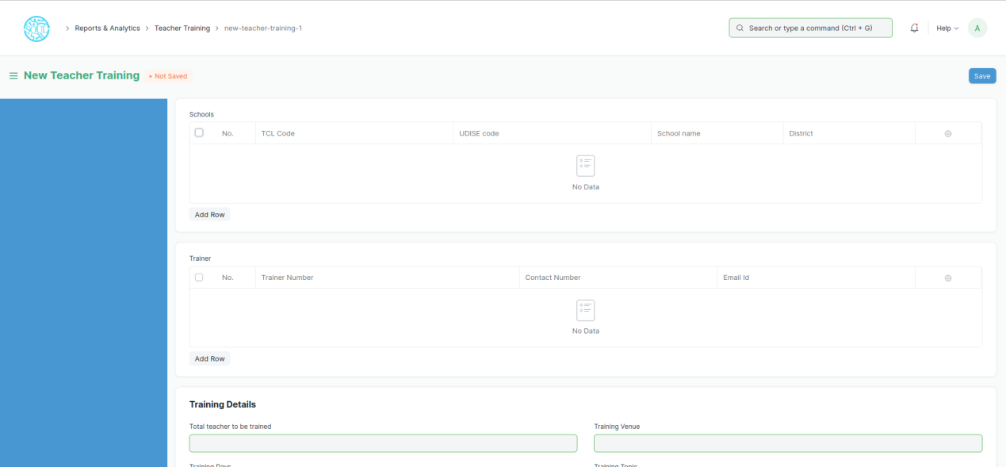

Figure 29: New Teacher Training

* **In order to add Schools related to Teacher Training, go to the ‘Schools’ table.**
* **Click on ‘Add Row’ button**

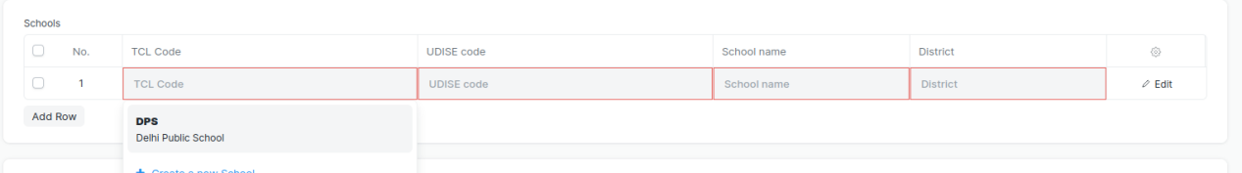

Figure 30: On Click of the Add Row button

* **Once the row is added**, **select the school by clicking on the TCL Code field on that row**
* **After School selection**, **all the details of that school will be fetched on the row**
* **In order to add Trainers related to Teacher Training, go to the ‘Trainer’ table.**
* **Click on ‘Add Row’ button**

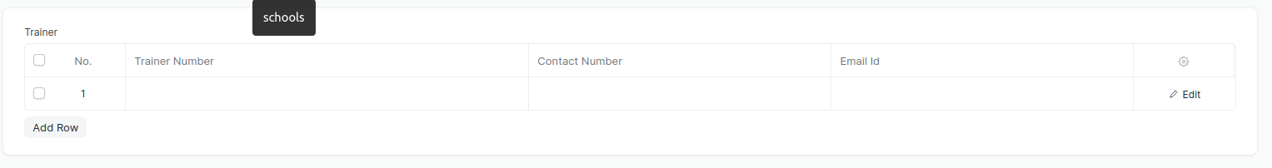

Figure 31: On Click of the Add Row button

* **Once the row is added, Enter the trainer number, Contact Number and Email ID on the relevant fields on that row**
* **You can also add multiple rows in each of the tables**
* **After Schools and Trainers have been added, enter the training details in the next section with relevant information in the fields such as Total teacher to be trained, Training Days, Per session (Hours), From Date, End date, Training Venue,Training Topic.**
* **After training details have been added, add the participants which are already present in the form of Teacher Group. Just add teacher group and school consent for teacher training from the dropdown.**
* **After adding the Participants and School Consent successfully, you can also attach attachment of various sorts such as Training Photos Attachment, Training Attendance Attachment, Training Recording Attachment, Training Assessment Attachment, Feedback Attachment, Venue Pictures attachment.**
* **In order to attach these attachments, goto to the related tables and click on ‘Add Row’ button to add a row and then press the attach button to attach the documents.**

****Figure 32: On Click of the Add Row button Training Photos Attachment

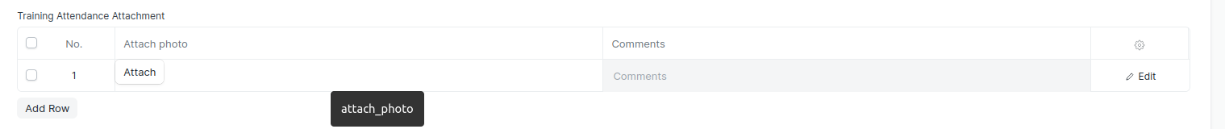

Figure 32: On Click of the Add Row button Training Attendance Attachment

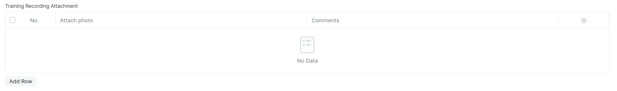

Figure 33: On Click of the Add Row button Training Recording Attachment

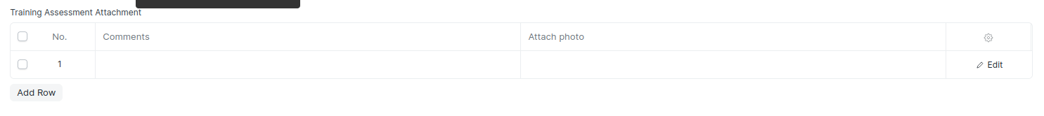

Figure 34: On Click of the Add Row button Training Assessment Attachment

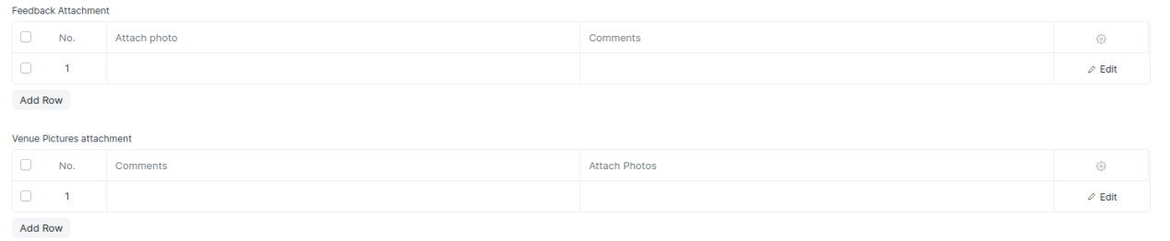

Figure 35: Feedback Attachment and Venue Pictures

* **Use the Attach button by clicking on it. You can also multiple rows by clicking on the ‘Add Row’ button multiple times.**

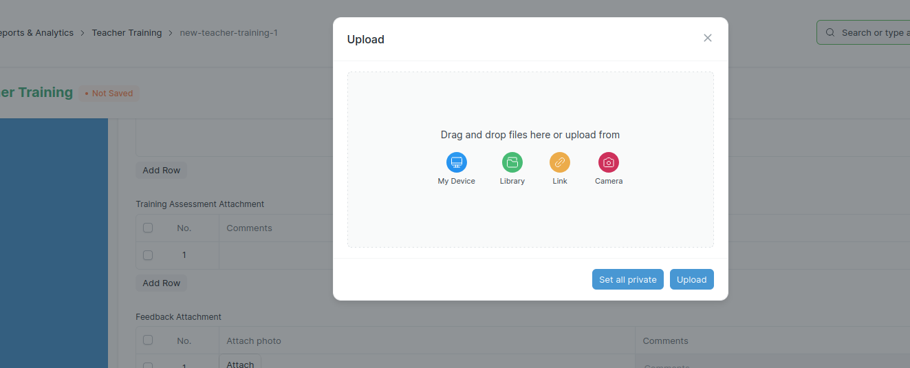

Figure 36: My Device to upload files/photos from your system

# Student Entry

**The Student Entry is used to keep a class-wise records of students in a school.**

**Home > BEPC > School Masters > Student Entry**



Figure 37: School Masters > Student Entry

* 1. ****How to Create Student Entry****
* **Go to Student Entry**
* **Click on + Add Student Entry**

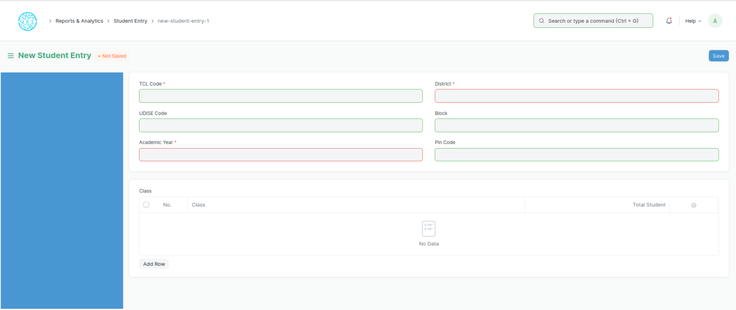

Figure 38: New Student Entry

* **In order to add Student Entry, Select the TCL Code of the school to fetch the school details.**
* **Then goto the Class Table to add class details and other required fields**
* **Click on ‘Add Row’ button**

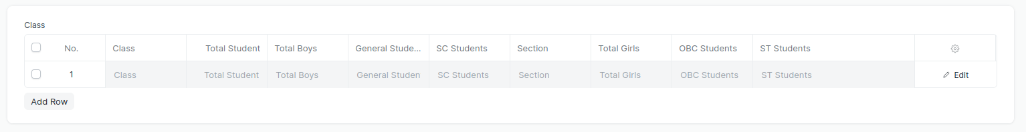

Figure 39: On Click of Add Row button

* **After a row is added enter the Class, Total Student, Total Boys, General Students, SC Student, Section, Total Girls, OBS Students, ST Students in the respective columns**
* **You can also added Class details of multiple classes by adding multiple rows by following the above process**
* **Click on Save button to save the form**

# Item

**You can add an Item as per requirement and its reference insurance company so that you can track which item is insured by which insurance company.**

**Home > BEPC > Theft & Insurance Master > Item**



Figure 40: Theft & Insurance Master > Item

**Prior to adding a Item record, the following must be created:**

* Insurance Company
  1. ****How to Create Item****
* **Go to Item**
* **Click on + Add Item**

****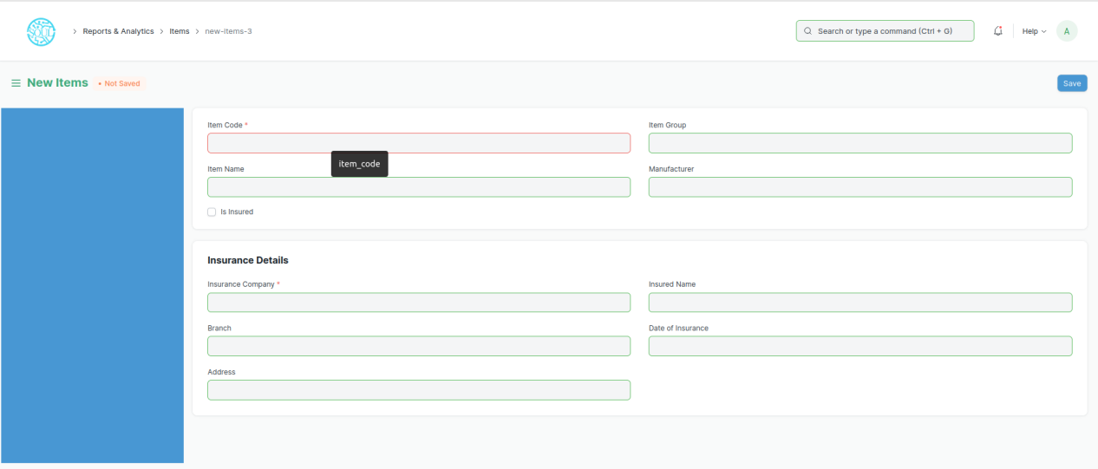****

Figure 41: New Item

* **Enter Item Code, Item Group, Item Name, Manufacturer to the respective fields**
* **Check(click to check) the checkbox ‘Is Enabled’ to enable the item and uncheck the checkbox to disable the item**
* **Finally, add the insurance details by filly the following fields such as Insurance company, Branch, Address, Insured Name, Date of Insurance**
* **Click on Save button to Save the form**

# Insurance Company

**This form enables us to store critical information about the insurance company providing insurance for the items used in the organization.**

**Home > BEPC > Theft & Insurance Master > Item**



Figure 42: Theft & Insurance Master > Insurance Company

* 1. ****How to Create Insurance Company****
* **Go to Insurance Company**
* **Click on + Add Insurance Company**

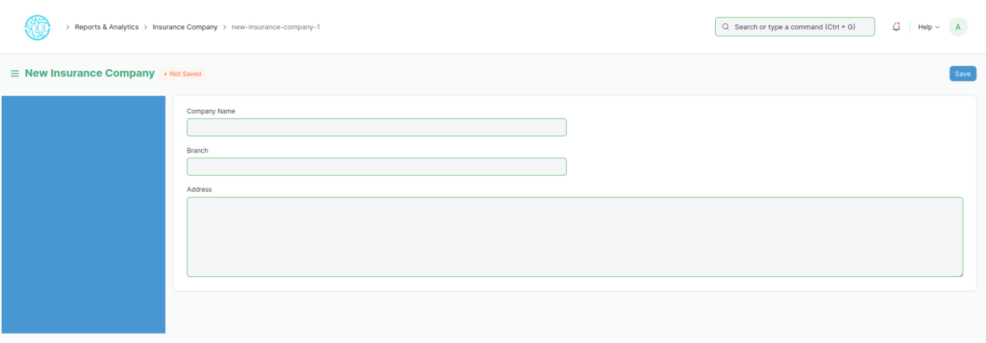

Figure 43: New Insurance Company

* **Enter the Company Name, Branch of the company and Address in the respective fields**
* **Click on Save Button to save.**
* **Your Insurance Company will be saved for further use**

# School Wise Equipment List

**This form enables us to store critical information about the items stored/used in a school.**

**Prior to adding a School Wise Equipment List record, the following must be created:**

* Item
* School

**Home > BEPC > Theft & Insurance Master > School Wise Equipment List**



Figure 44: Theft & Insurance Master > School-Wise Equipment List

* 1. ****How to Create School Wise Equipment List****
* **Go to School Wise Equipment List**
* **Click on + Add School Wise Equipment List**

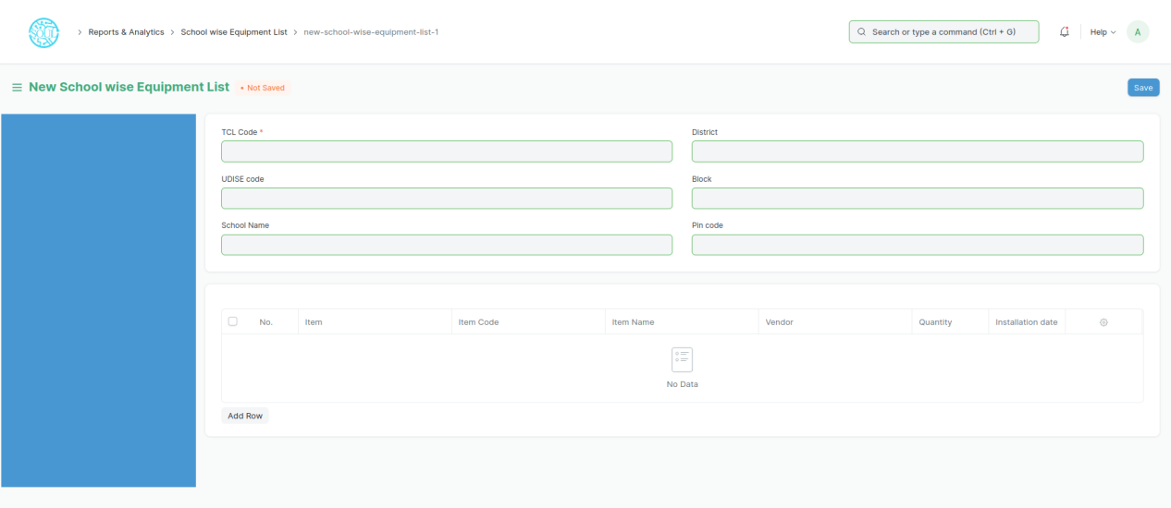

Figure 45: New School-Wise Equipment List

* **Enter the TCL Code of the school for which the equipment are to be recorded**
* **Go to the table below and click on Add Row button to add an item**

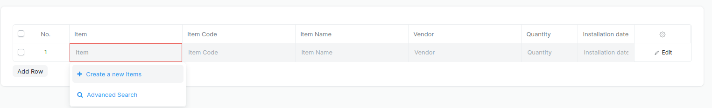

Figure 46: On Click of Add Row Button

* **Enter the TCL Code of the school for which the equipment are to be recorded**
* **Go to the table below and click on Add Row button to add an item**
* **You can add multiple items by using the Add Row button multiple times**
* **Click on the Save button to save the form**

# Theft Case Record

**Theft Case Record is used to record theft cases of the items used in the organization**

**Prior to adding a Theft Case record, the following must be created:**

* Items
* School

****Home > BEPC > Theft & Insurance Master > School Wise Equipment List****



Figure 47: **Theft Insurance Monitor > Theft Case** Record

* 1. ****How to Create Theft Case Record List****
* **Go to Theft Case Record**
* **Click on + Add Theft Case Record List**

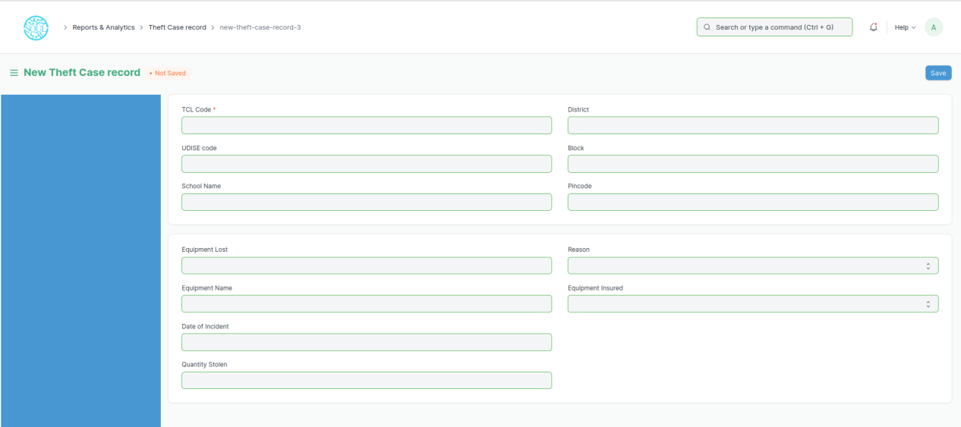

Figure 48: New Theft Case Record

* **Enter the TCL Code of the school where the theft has occurred**
* **Enter the Item stolen in the equipment lost field**
* **Enter the Date of Incident, Quantity Stolen, Reason, and Equipment Insured in the respective fields**
* **Click on the Save button to save the form**

# School Survey Form Update Status

**After login, navigate to reports :**

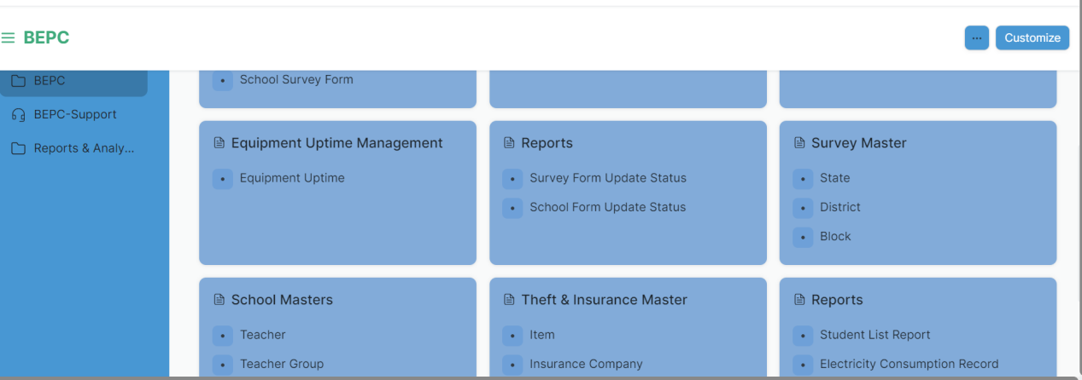

Figure 49: Survey Form Update Status

**Irrespective of the selected reports (Survey Form Update Status or School Form Update Status) , click on Show Report button. Click on Filter button on the next screen that appears.**

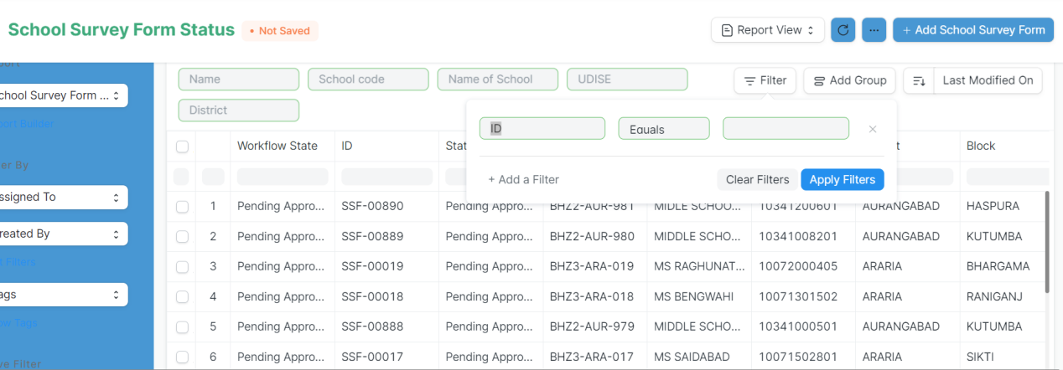

Figure 50: School Survey Form Status Filters

**In ID field, enter “**Last Updated On**”. Click on the date field to enter the date range to see the records for the entered date range. For example : as shown below.**

**Please note : You need to select From Date and To Date in the same field.**

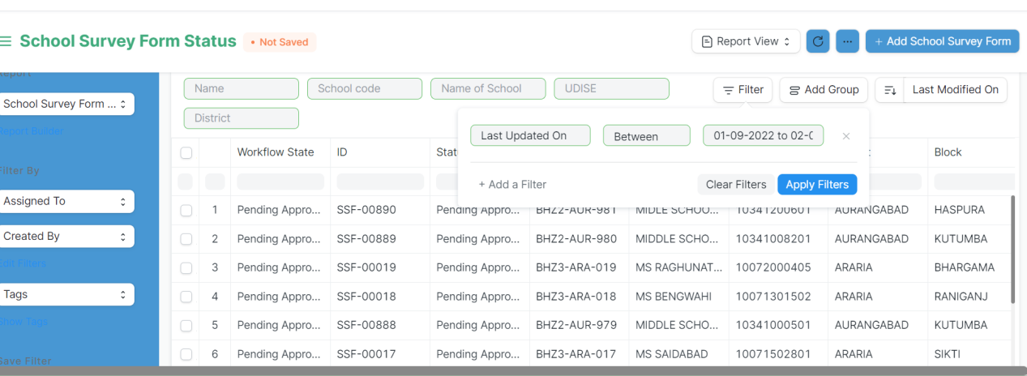

Figure 51: School Survey Form Status Filters

**If you want to view the summary, click on “Add Group”.**

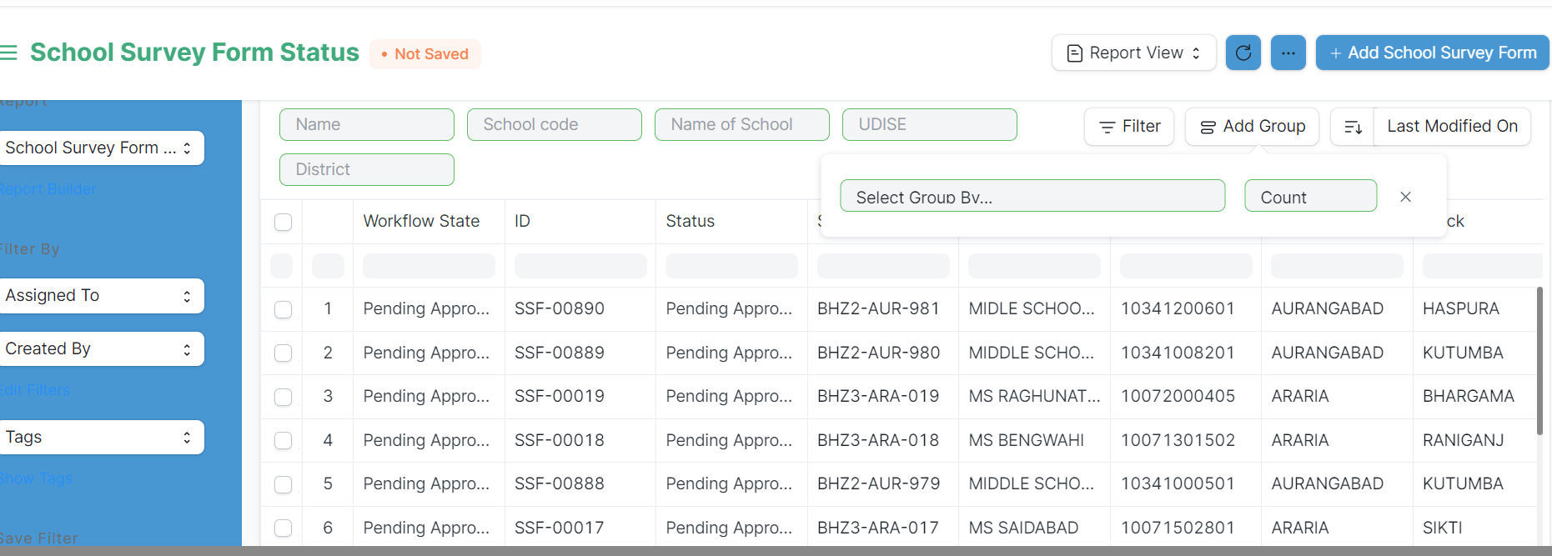

Figure 52: School Survey Form Status

**In Add Group drop down, select “Workflow State” to get the summary as shown below**

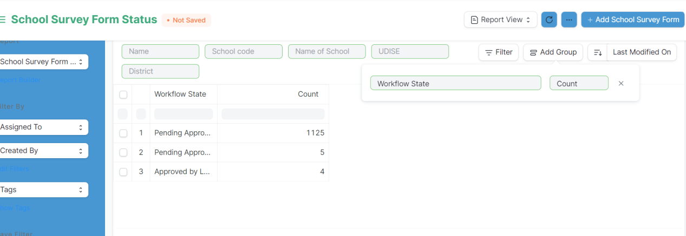

Figure 53: School Survey Form Status workflow state

# School Wise Student

**School Wise Student report allows us to view the details of students with reference to schools**

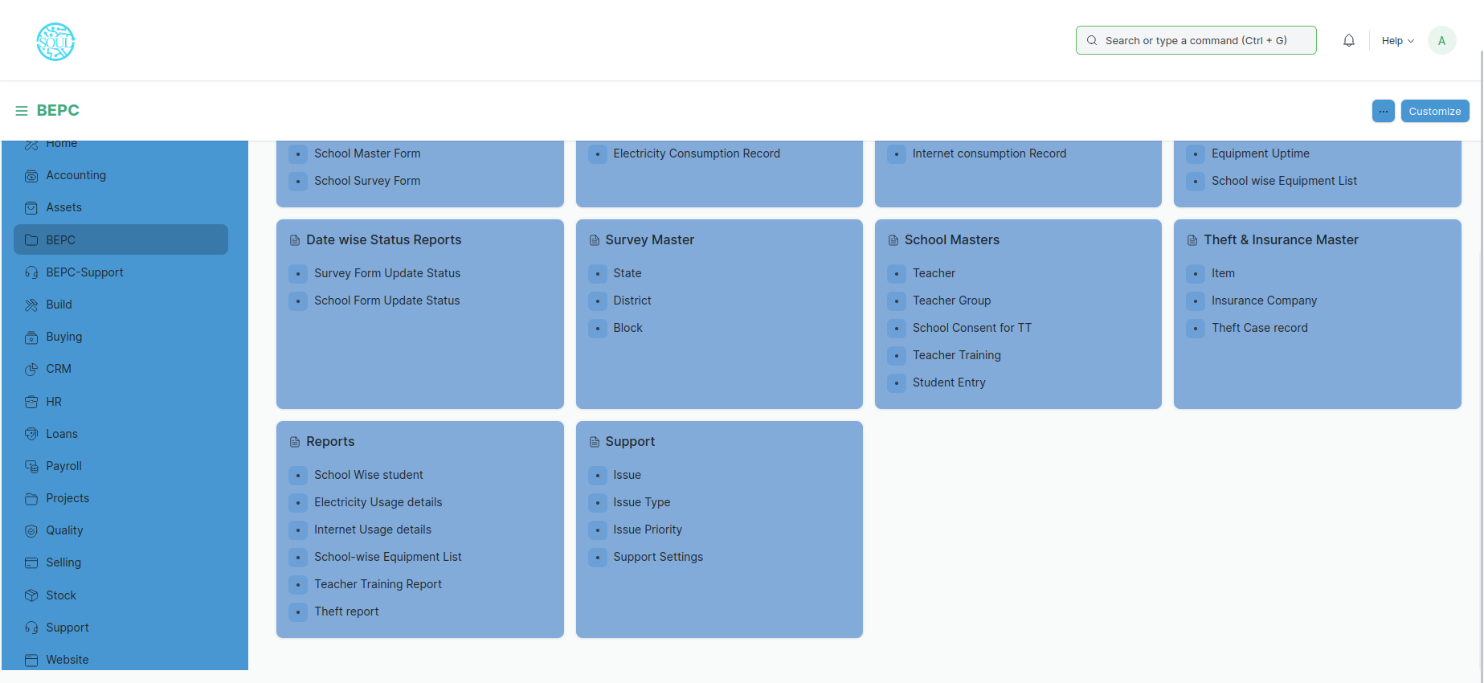

Figure 54: School Wise Student

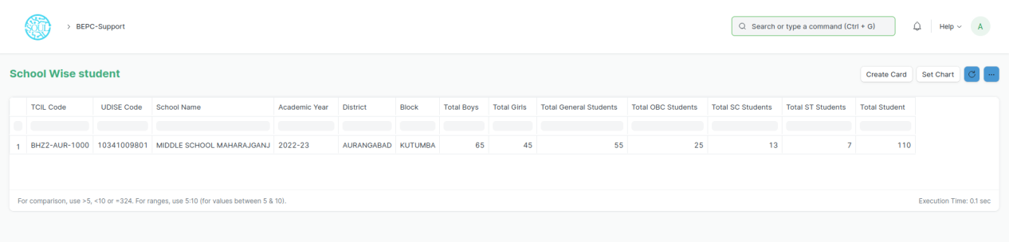

# Figure 55: School Wise Student Report

# Electricity Usage Details

**This report assists us to analyse the electricity usage and meter readings as well as submeter reading of all the schools in a single space**



Figure 56: Electricity Usage Details

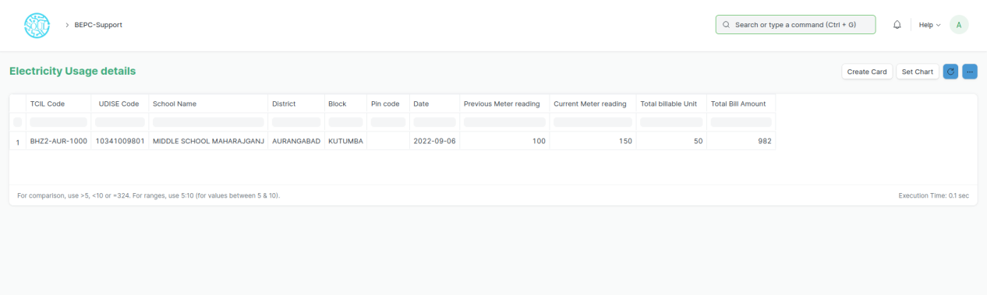

Figure 57: Electricity Usage Details Report

# Internet Usage Details

**Internet Usage Details is used to analyse the internet usage of all the schools. The unit of measurement is in gigabytes and the cost is also mentioned along with the Internet Service Provider**



Figure 58: Internet Usage Details

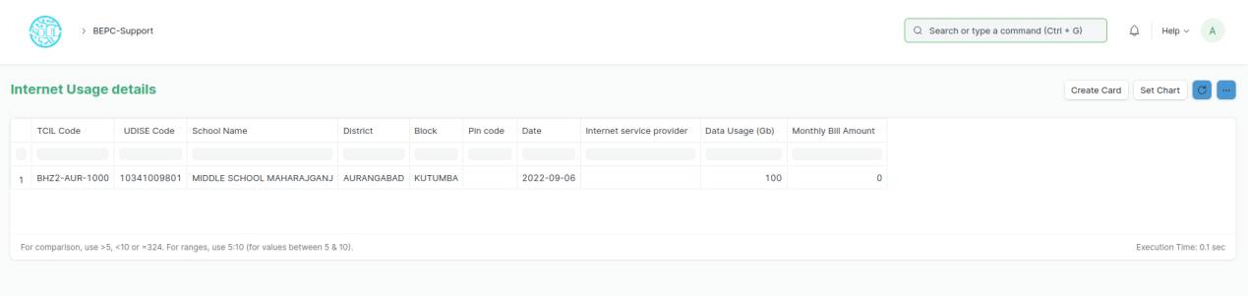

Figure 59: Internet Usage Details Report

# School Wise Equipment List

**As the name suggests, this report gives a detailed overview of the equipment present in all the schools along with its serial number, MAC id and installation date**



Figure 60: School Wise Equipment List

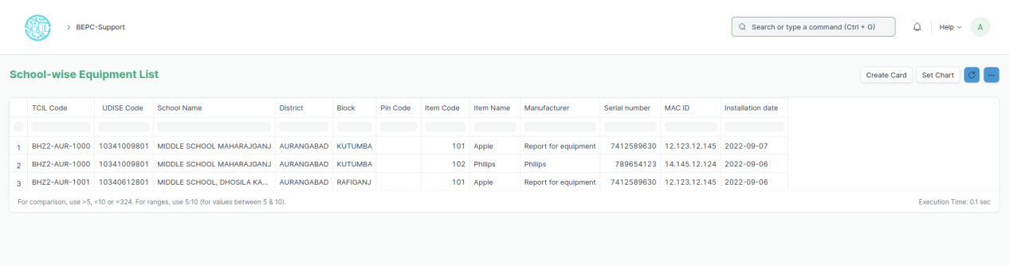

Figure 61: School Wise Equipment List

# Teacher Training Report

**Teacher Training Report can be used to identify the training process of the teachers with reference to teacher groups and the details of trainers, venues, training topic etc. assigned to teach the teacher groups.**



Figure 62: Teacher Training Report

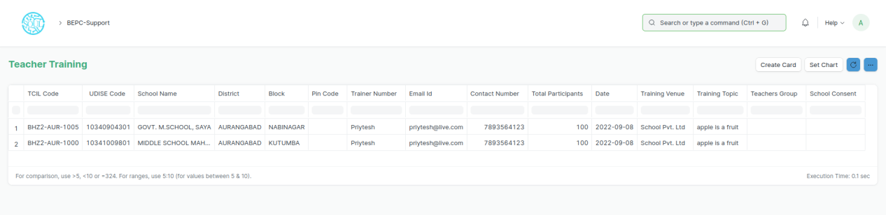

Figure 63: Teacher Training Report

# Theft Report

**This report gives a detailed overview of the theft case that has occurred and gives us all the details such as school from which the item was stolen, equipment name, date of incident, quantity stolen etc.**



Figure 64: Theft Report Navigation

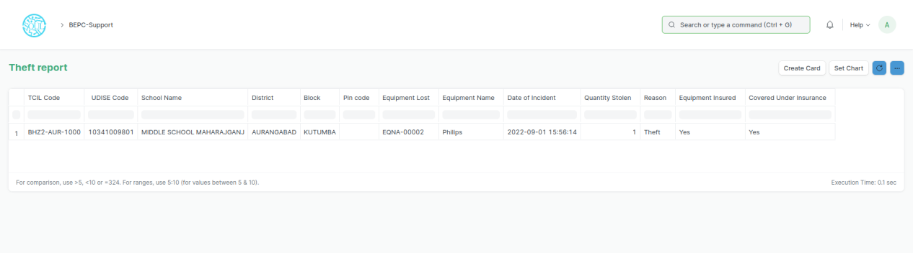

Figure 65: Theft Report

# BEPC Support

**Great customer support and maintenance is at the heart of any successful business. With BEPC Support, you track all incoming customer requests and issues and respond to them quickly. The database of incoming queries will also help you to identify the biggest opportunities for improvements.**

**You can track incoming queries from your email using Support Tickets. You can keep track of Customer Issues linked with a specific Serial No and respond to them based on their warranty and other information. You can also make Maintenance Schedules for Serial Nos and keep a record of all Maintenance Visits made to your Customers.**

* 1. ****Support Settings****

**All the global settings for support related documents can be found in Support Settings.**

**To access Support Settings, go to:**

**Home > BEPC > Support > Support Settings**



Figure 66: Support Settings

****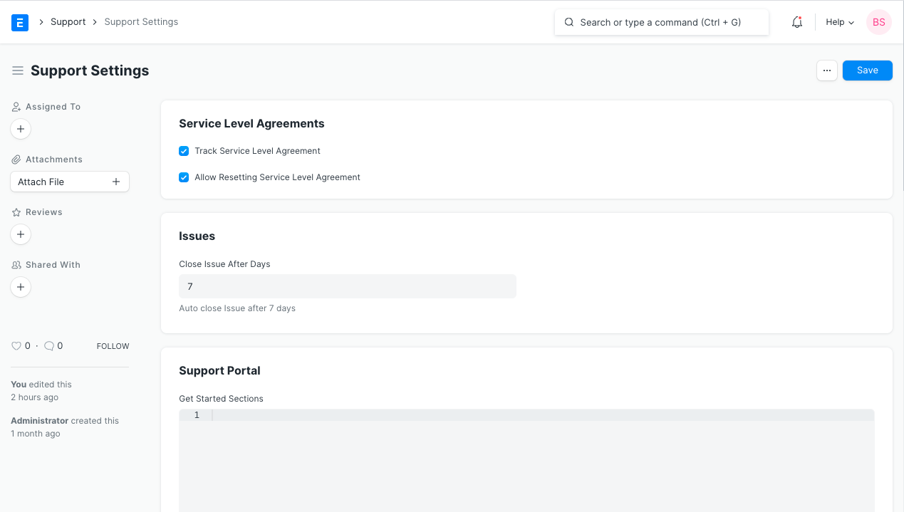****

Figure 67: Support Settings screen

* 1. ****Service Level Agreement****

**A service level agreement (SLA) is a contract between a service provider (either internal or external) and the end user on the level of service expected from the service provider.**

**SLAs are output-based, their purpose is specifically to define the timeline in which the Customer will receive the service. SLAs do not define how the service itself is provided or delivered.**

**To access the Service Level Agreement list, go to:**

**Home > BEPC > Support > Service Level Agreement**

**Before creating and using a Service Level Agreement, it is advised that you create/update the following first:**

* **[Holiday List](https://docs.erpnext.com/docs/v13/user/manual/en/human-resources/holiday-list)**
* **Enable Track Service Level Agreement in Support Settings**

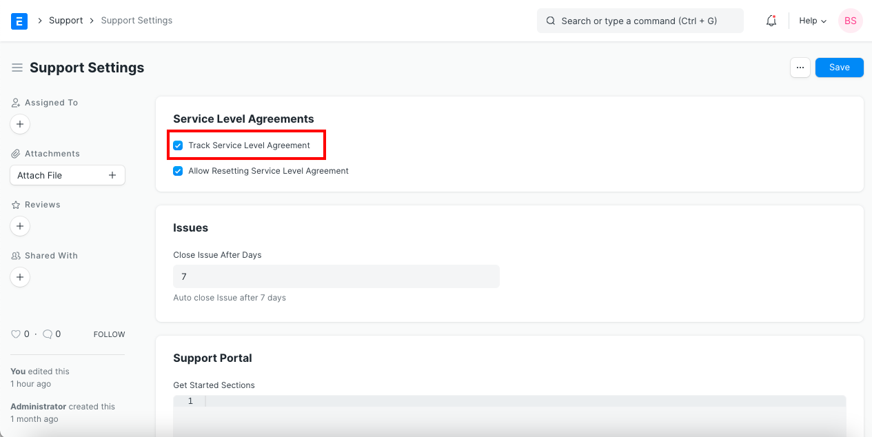

Figure 68: Support Settings - track SLA

* **Go to the Service Level Agreement list, click on New.**
* **Enter a name for the Service Level.**
* **Select an Employee group, that will handle a particular Service Level.**
* **Set a Holiday List. Service Level Agreement won't be applied in the days mentioned in the Holiday List.**
* **'Enable' determines if a Service Level Agreement is enabled or disabled.**
* **Ticking 'Default Service Level Agreement' will apply this SLA to a customer if they don't have a particular SLA assigned to them.**
* **Entity Type: Service Level Agreements can be assigned to a Customer/Customer Group/Territory enabling you to apply Service Level Agreement based on these factors.**
* **Entity: Select the specific Customer/Customer Group/Territory.**
* **Start / End Date: Defines the validity of the agreement.**
* **Priorities: You can set multiple Issue Priorities and their Time to Respond and Resolve (in hours and mins).**

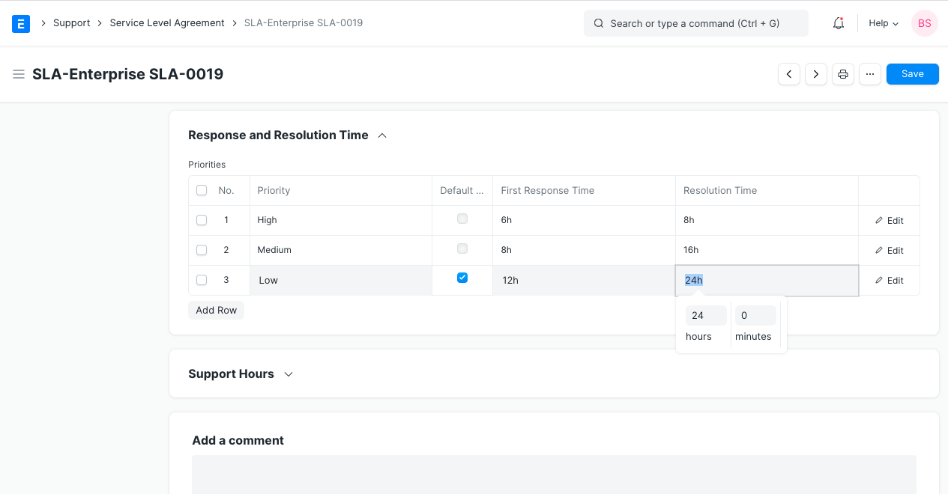

Figure 69: Response and Resolution Time

* **Default Priority: Default Priority selected in Priorities table that will be applied in the Service Level Agreement.**
* **Support Hours: Contains the Days of the week on which Support is provided. Has a Start Time and End Time of the Working day.**

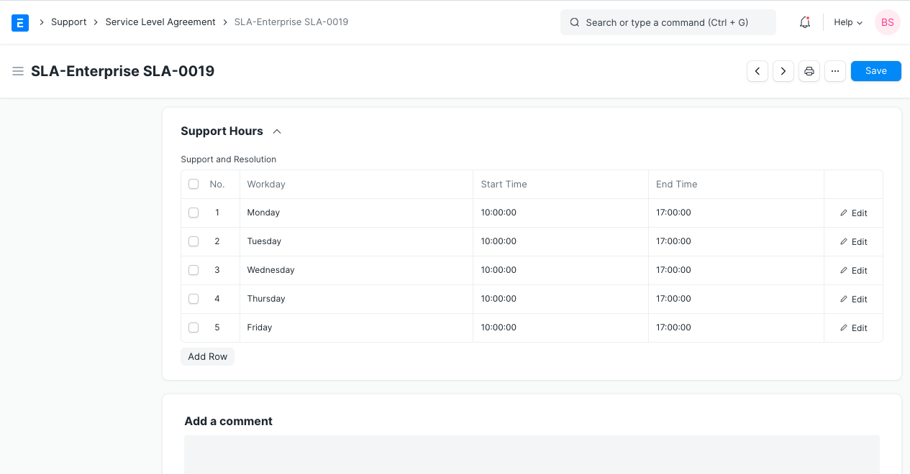

Figure 70: SLA Support Hours

* **Save**
  1. ****Features of Service Level Agreement****

### **>>** Applies to New Issues

**Once an SLA is saved, it'll be applied to Issues raised by Customers/Territories as per the option you chose in 'Entity Type'.**

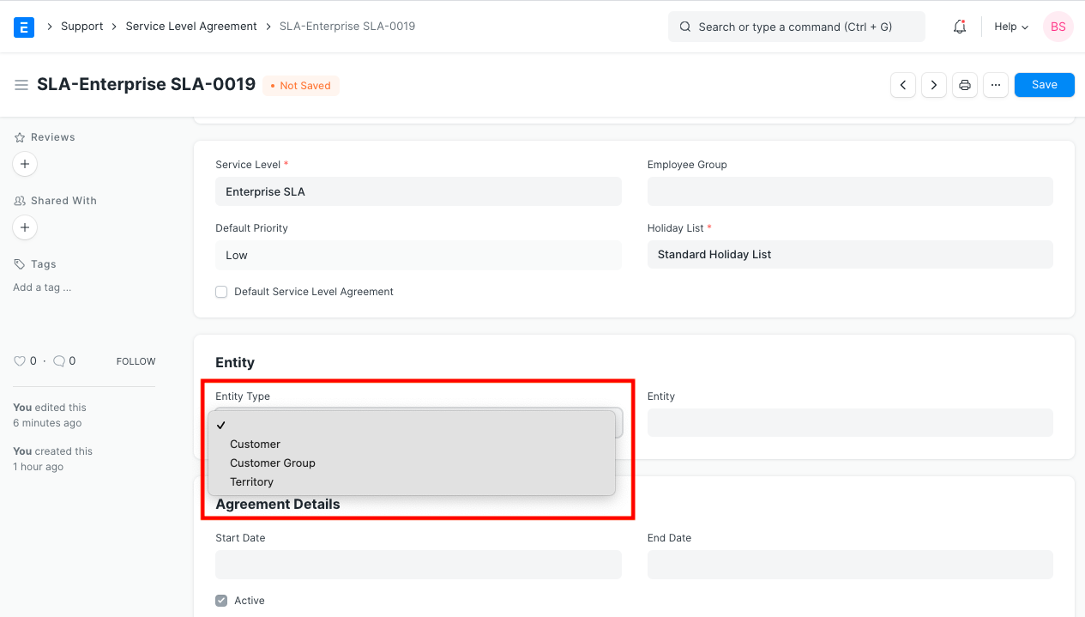

Figure 71: SLA Entity Type

### >> Resetting an SLA

**An SLA can also be reset until the time does not fail. For example, if the SLA is 3 days, you can reset the SLA only within 3 days of the Issue being created. After that, the Service Level will display failed.**

### >> Time respond / resolve in Issues

**The time to respond to an Issue and the time to resolve will be shown:**

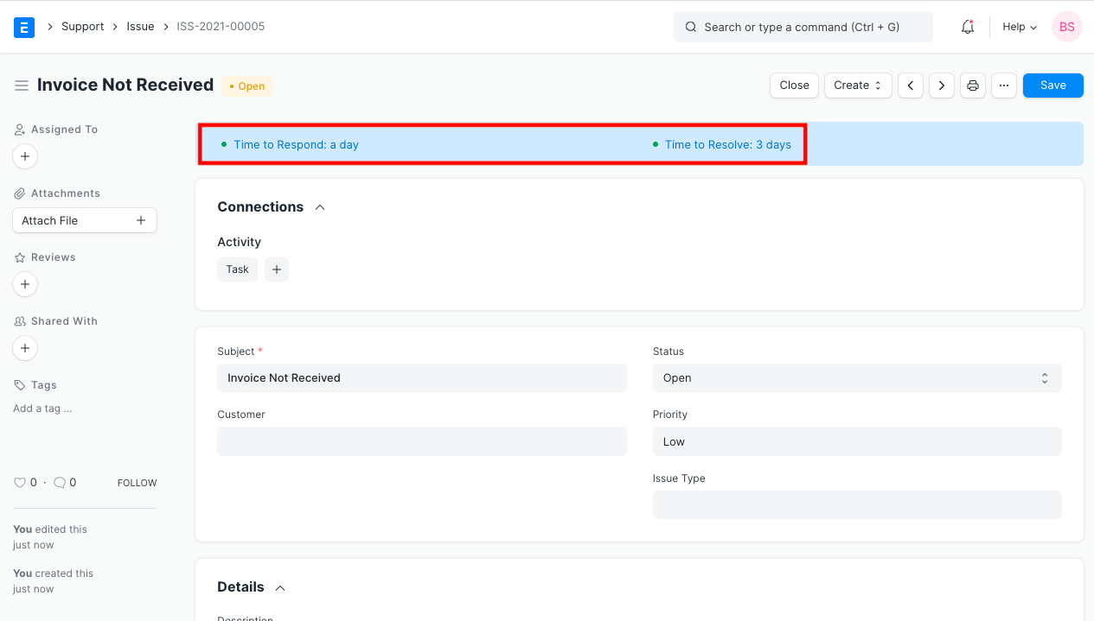

Figure 72: Time to respond

**These times are based on the timelines set in the 'Priority' field in the Service Level's Priorities table.**

### >> Pause SLA on Statuses

**BEPC Support allows you to pause SLA on issues when you are waiting for an event to happen. You can do this by selecting a status that is configured in this "Pause SLA On" table.**

* **Set the statuses on which you want to pause SLA in the SLA document. You can also add custom statuses here.**

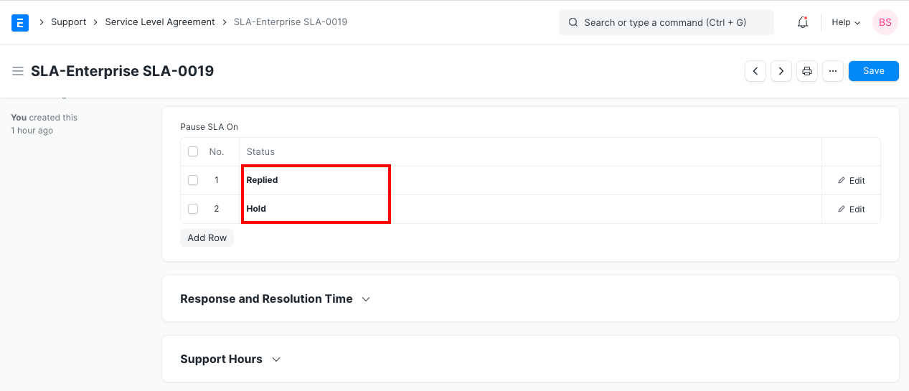

Figure 73: Pause SLA

* **When the status is changed to any of the above, resolution and response fields are unset and the dashboard indicators change to:**

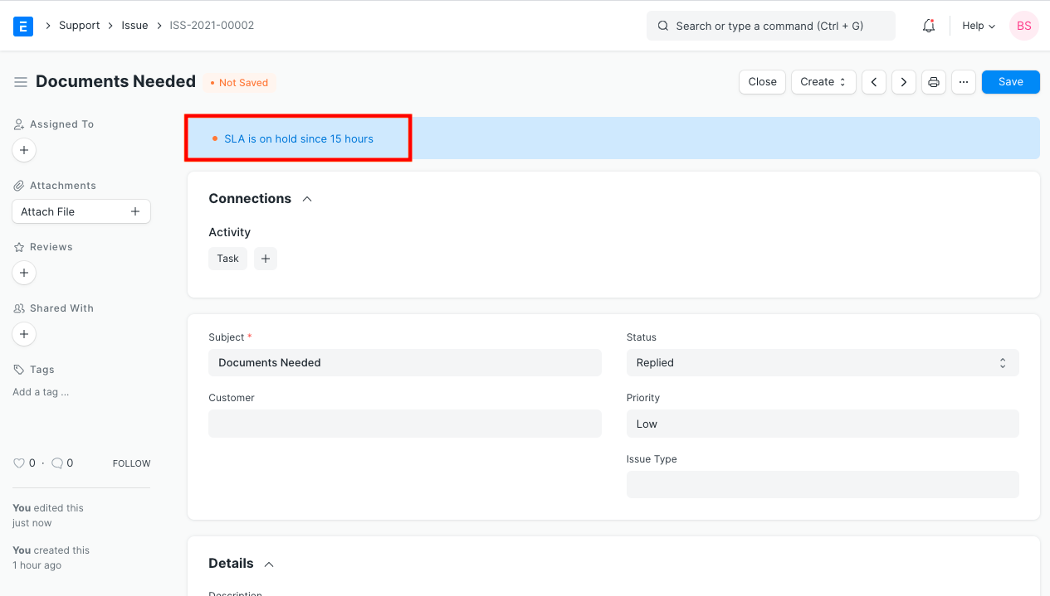

Figure 74: Hold Indicator

* **When the status of the issue changes back to a non-hold status (which is not configured in the "Pause SLA On" table), the Total Hold time field will be set in your Issue document.**

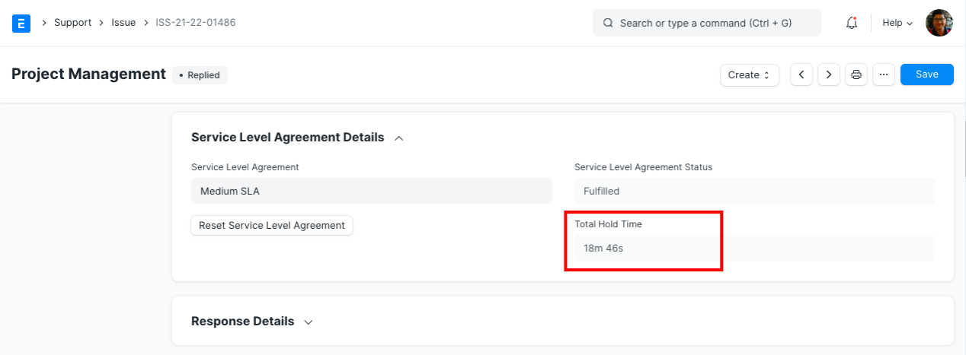

Figure 75: Total Hold Time

**The Response and Resolution time will be recalculated by adding the hold time, thereby restarting your SLA timers.**

* 1. ****Issue Priority****

**The priority of issues can be set using Issue Priority.**

**To access the Issue Priority list, go to:**

**Home > BEPC > Support > Issue Priority**



Figure 76: Issue Priority

**Go to Issue Priority >> Click on New**

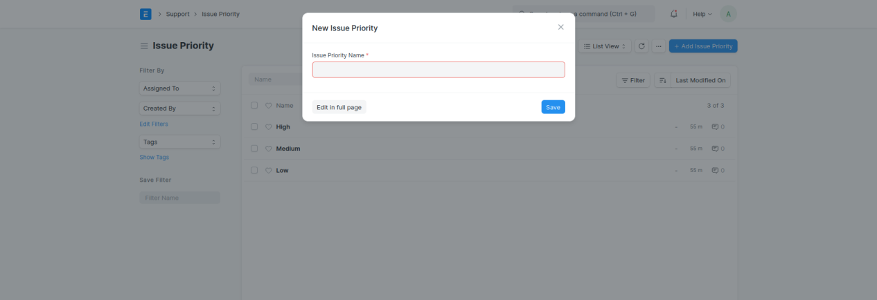

Figure 77: New Issue Priority

* 1. ****Issue Type****

**The type of issues can be set using Issue Type.**

**To access the Issue Type list, go to:**

**Home > BEPC > Support > Issue Type**



Figure 78: Issue Type

**Go to Issue Type >> Click on New**

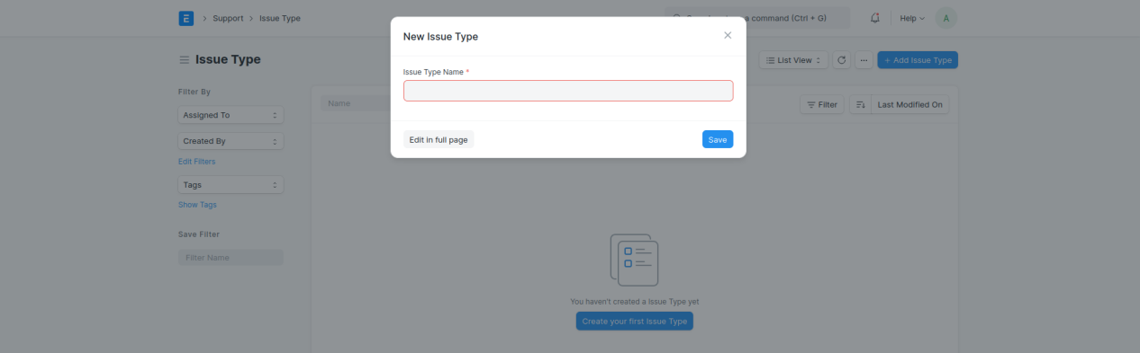

Figure 79: New Issue Type

* 1. ****Issue****

**An Issue is an incoming query from a Customer, usually via email or from the Contact section of your website.**

**To access the Issue list, go to:**

**Home > BEPC > Support > Issue**



Figure 80: Support > Issue

* **Go to the Issue list, click on + New Issue**
* **Click on Edit in full page button**
* **Enter the Subject, Raised By, and a description of the Issue**
* **Additional Options while creating an Issue:**

**Status: When a new Issue is created, its status will be "Open", when it is replied, its status becomes "Replied".**

* + **Open: The Issue has been created and yet to be replied to.**
  + **Replied: A reply has been sent to the Issue.**
  + **Hold: The Issue is on Hold due to some reason.**
  + **Resolved: When the users are reasonably sure that they have provided the customer with a solution to their problem but have not received an acknowledgment about the resolution from the customer.**
  + **Closed: The Customer got a satisfactory resolution that he has indicated with an acknowledgment and the Issue was closed.**
  + **If the sender replies to the thread, the status becomes "Open" again. User can "Close" the Issue manually by clicking on the Close button on the top right.**

Note: If SLA has been set up, then the fulfillment status of the SLA will be updated on both, the **Closed** as well as the **Resolved** status.

* + **Priority: Priority can be set as per the requirements. By default, there are three priorities--Low, Medium, and High. You can delete these or add more as needed.**
  + **Issue Type: An Issue can be classified using Issue Type. Examples of Issue Types can be: 'Functional', 'Technical', 'Hardware', etc.**
  + **Raised By (Email): The email ID from which the Issue was sent will be shown here.**
* **Details:**
  + ****Description**: This is a text field in which details about the Issue can be seen. This can also contain an image or a table.**
* **Service Level Agreement**

**It is a contract between a service provider and the end user that defines the level of service expected from the service provider.**

**User can select the [Service Level Agreement](https://docs.erpnext.com/docs/v13/user/manual/en/support/service-level-agreement) (SLA) from the list.**

* + **Every Issue will have a Time to Response and Time to Resolve within which the Support team has to Respond and Resolve the Issue.**
  + **The Priority can be changed to escalate the Issue. The priorities need to be specified in the Service Level Agreement.**
  + **If needed, the Service Level Agreement can be reset by clicking on the Reset Service Level Agreement button in Issues shown as follows:**
* **Response**
  + ****Mins to First Response**: Time in minutes from when the Issue was created to when the first reply was sent.**
  + ****First Responded on**: When a Support team member first replies to the issue, first response date and time will be updated.**
  + ****Average Response Time**: The average time taken to respond to the Customer. This is calculated by taking the average of all time spans between Received and Sent Communications. This field will be updated on every reply sent to the customer.**
* **Reference**

**User can filter the issues based on these fields linked to the Issue:**

* + **Lead**
  + **Contact**
  + **Email Account**
  + **Project**
  + **Company**
* **Resolution**
  + **Opening Date: When the issue is created or logged the date be posted.**
  + **Opening Time: When the issue is created or logged the exact time will automatically be posted.**
  + **Resolution Date: When the user resolved the issue, Date and Time will get updated in this field.**
  + **Resolution Details: User can enter the details of the issue, once it is resolved. This is a text field. Also, user can upload the image, enter or create a table.**
  + **Resolution Time: Total time taken to close the ticket (from Issue creation to closing).**
  + **User Resolution Time: Many times a user has to wait for a customer's reply in order to solve some Issue. While measuring User's productivity this wait time shouldn't be taken into consideration. Hence, user resolution time is the total time taken by a user to close the ticket and can be calculated as:**
  + **Resolution time - Total Time for which the user had to wait for a customer's reply**

**The Resolution Time and User Resolution Time metrics are set on "Close". These metrics reset automatically when the Issue reopens or splits.**